4 R A R / 4 R A R (COMMANDO) HISTORY ROOM
Patron – Brigadier The Honourable David Thomson, MC (RL

PO Box 377 CONCORD NSW 2137

ACN 107 059 512 ABN 12 107 059 512
Mobile 0438 532208 Telephone 02 9745 1786
(Chairman – David Morris)

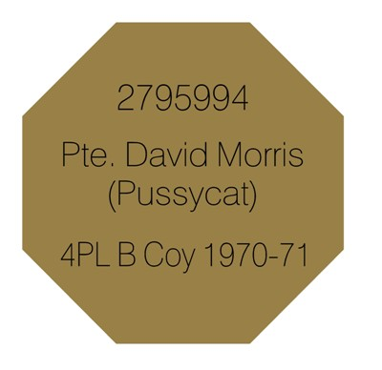

Simply provide the details you want on your plaque on the form:
Keep in mind the size

Service No (Optional)
Rank (Optional)
Name
Nickname
Tours e.g. Borneo, Malaya, Vietnam, East Timor, Iraq
Section, Platoon Company
Battalion: 4RAR, 4RAR(NZ), 2/4 RAR, 4RAR(Cdo) (Optional)

We will engrave what best fits on the plaque

POST TO: The Treasurer
PO Box 377
Concord NSW 2137

Cheque or Money Order

Order Form

Service No.: ……………………………………………………………...

RANK: …………………………………………………………………….

NAME: ……………………………………………………………………

NICKNAME: ……………………………………………………………...

Sub-Unit: ……………………………………UNIT……………………

Tours: ……………………………………………………………………..

