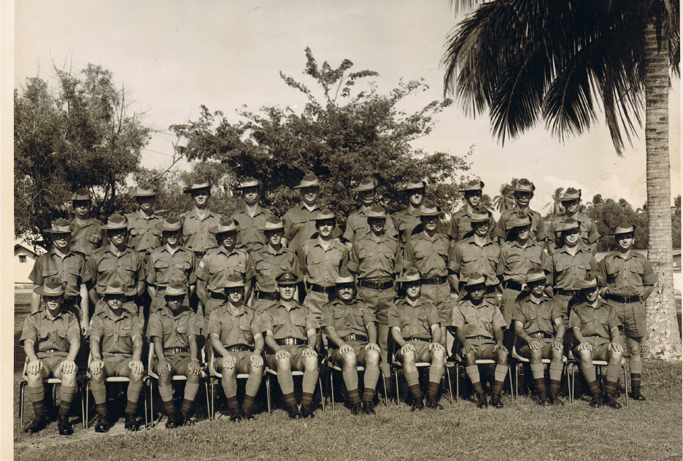

B Company 2/4 RAR
Butterworth Sept/Nov 1975

Back Row (left to right)
L/Cpl Asbry, Pte Jones, Pte Hughes, Pte Killen, Pte Moore, L/Cpl Percks, Pte Egan, Pte Tindal, Pte Schlegel,
Pte Cheeseman.

Centre Row (left to right)
Cpl Russell, Pte King, Pte Clancy, L/Cpl Sheilds, Pte Nobbs, Pte Wood, L/Cpl Bryce, Pte Twomey, Pte French, Cpl Walker, Spr Adamson, Spr Glekas.

Front Row (left to right)
L/Cpl Cameron, Cpl Dowell, Pte Rainford, Pte Dillon, 2nd Lt Buck, Sgt Graham, Pte Hahish, Pte Rushbrook,
Spr Smith, Pte McDonald.

